**Forts:**

Red Fort

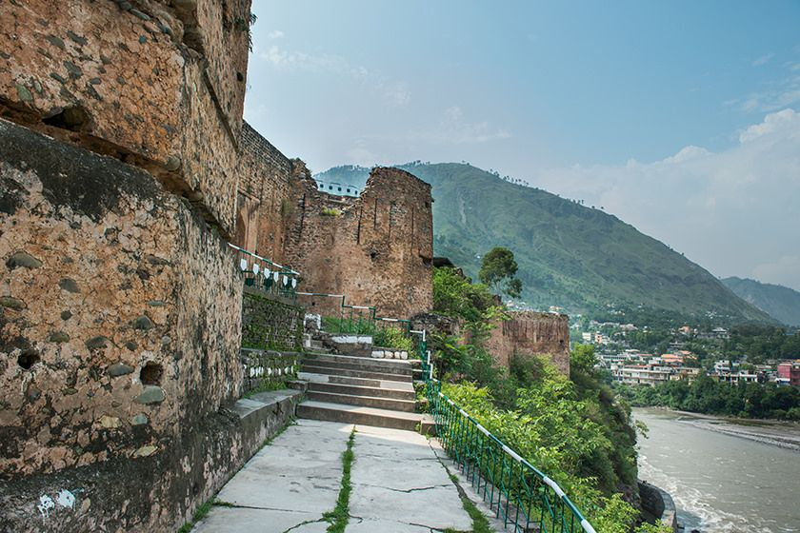

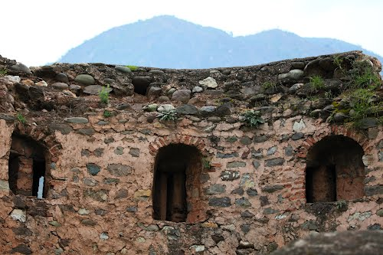

**Red Fort** - also known as the **Muzaffarabad Fort** was built by the Chak rulers of Kashmir in the 16th century. The current locality is called Center Plate. Locally, it is known as the "Rutta Qila" or just "qila".Chak rulers of Kashmir anticipated threat to the city from the Mughals. Construction was initiated in 1559 at a strategic location. The Mughal Empire annexed Kashmir in 1587, and the fort lost its importance.

Altit Fort

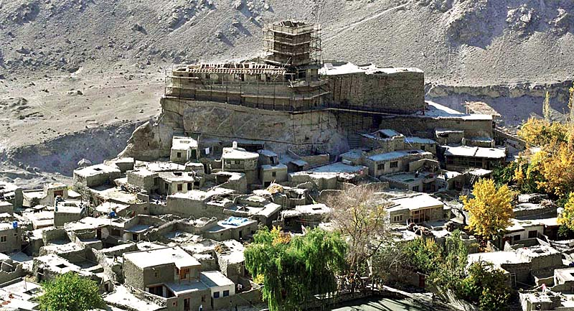

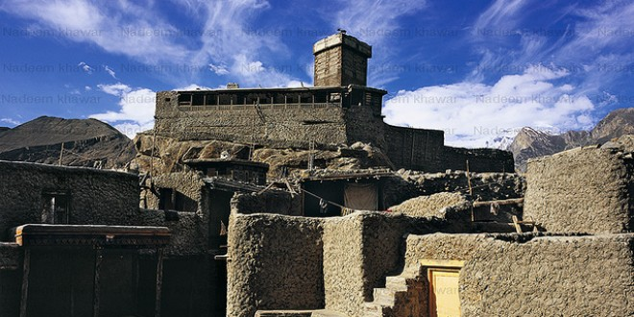

**Altit Fort** is an ancient fort at Altit town in the Hunza valley in Gilgit Baltistan, Pakistan. It was originally home to the hereditary rulers of the Hunza state who carried the title Mir, although they moved to the somewhat younger Baltit fort nearby three centuries later. Altit Fort and in particular the Shikari tower is around 1100 years old, which makes it the oldest monument in the Gilgit–Baltistan. The word Altit means *this side down* and the area around the fort is inhabited by Burusho people. The people of Altit are said to belong to the white Huns, although not much research has gone into the matter. There are several theories about their origin but local indigenous origin holds much value among the people.  It is also said that the present language Bruchiski was brought here by the white Huns in 47 A.D but there is no link between burushaski and any other language of today.  According to the legend the first name for Altit village was Hunukushal, meaning *the village of Huns*. The Huns came from the Huang-Ho valley in China. The name later changed to Broshal, translated as *a village of Bruchiski speakers*.  They were spirit worshipers as Shamanism was in practice and also followed Buddhism and Hinduism. In the 15th century Islam was introduced. Around 1830 in turn many converted to Ismailism.

Baltit Fort

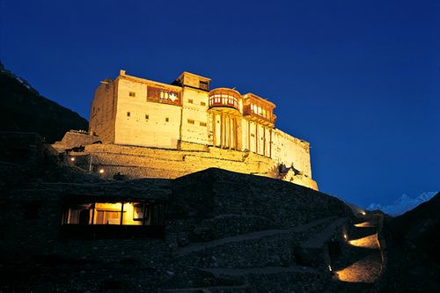

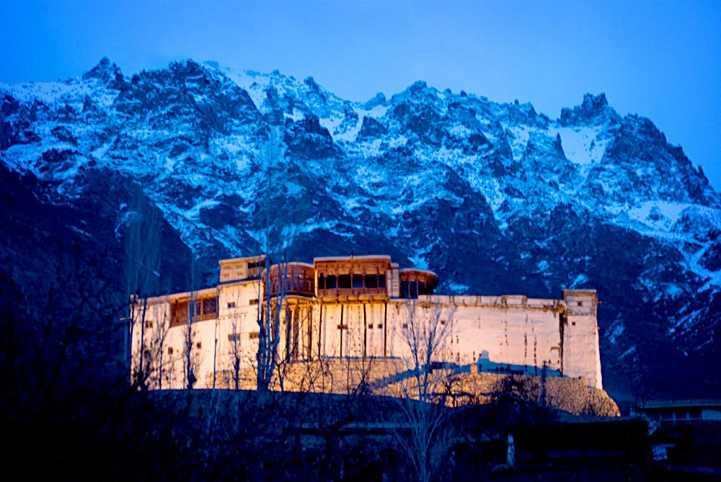

**Baltit Fort** is a fort in the Hunza valley, near the town of Karimabad, in the Gilgit-Baltistan region of northern Pakistan. Founded in the 8th CE, it has been on the UNESCO World Heritage Tentative list since 2004. In the past, the survival of the feudal regime of Hunza was ensured by the impressive fort, which overlooks Karimabad. The foundations of the fort date back to 700 years ago, with rebuilds and alterations over the centuries. In the 16th century the local prince married a princess from Baltistan who brought master Balti craftsmen to renovate the building as part of her dowry. The Mirs of Hunza abandoned the fort in 1945, and moved to a new palace down the hill. The fort started to decay which caused concern that it might possibly fall into ruin.

Bala Hissar Fort

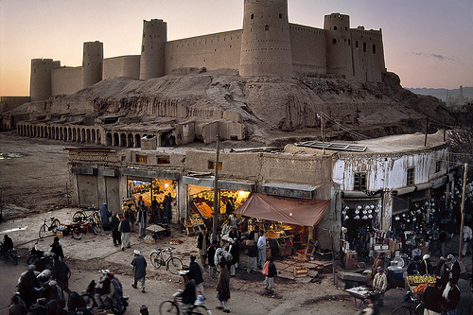

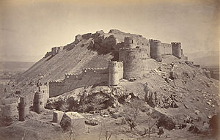

**Bala Hissar** also spelt **Bala Hisar**, is a historic fortress located in Peshawar, Khyber Pakhtunkhwa, Pakistan. The fort was used as a royal residence for the Durrani Empire, and was renovated during Sikh rule. The fort now serves as headquarters for Pakistan's Frontier Corps. The fort stands on a high mound in the northwestern corner of Peshawar City. Not long ago, the fort used to be conspicuously away from the old city of Peshawar, but now the construction of new buildings has covered space between the old city and the fort. However, the fort's position on a high mound gives a commanding and panoramic view of Peshawar and the entire Peshawar valley. On a clear day, one can see the mountains encircling Peshawar valley and beyond. The area covered by the inner wall of the fort is about 10 acres (40,000 m2) and the outer wall is about 15 acres (61,000 m2). The height of the fort is about 90 feet (27 m) above ground level.

Derawar Fort

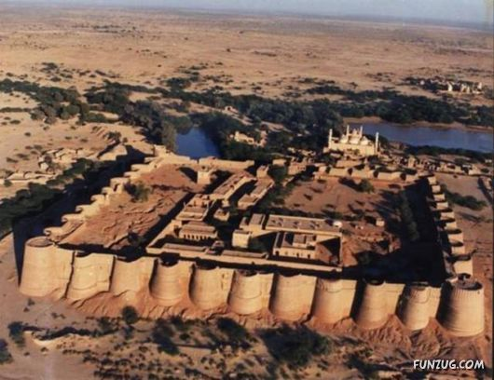

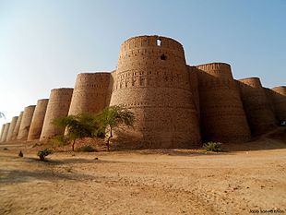

**Derawar Fort** is a large square fortress in Yazman Tehsil, Punjab, Pakistan. Approximately 130 km south of the city of Bahawalpur, the forty bastions of Derawar are visible for many miles in the Cholistan Desert. The walls have a perimeter of 1500 metres and stand up to thirty metres high. Derawar fort was first built in the 9th century AD by Rai Jajja Bhatti, a Hindu ruler of the Bhatti clan, as a tribute to Rawal Deoraj Bhatti, the king of Jaisalmer and Bahawalpur. The fort was initially known as *Dera Rawal*, and later referred to as *Dera Rawar*, which with the passage of time came to be pronounced *Derawar*, its present name. In the 18th century, the fort was taken over by Muslim Nawabs of Bahawalpur from the Shahotra tribe. It was later rebuilt in 1732 by Abbasi rulers Nawab Sadeq Muhammad, but in 1747 the fort slipped from their hands owing to Bahawal Khan's preoccupations at Shikarpur. Nawab Mubarak Khan took the stronghold back in 1804. 1,000 year-old catapult shells were found in the debris near a decaying wall in the fort.

Skardu Fort

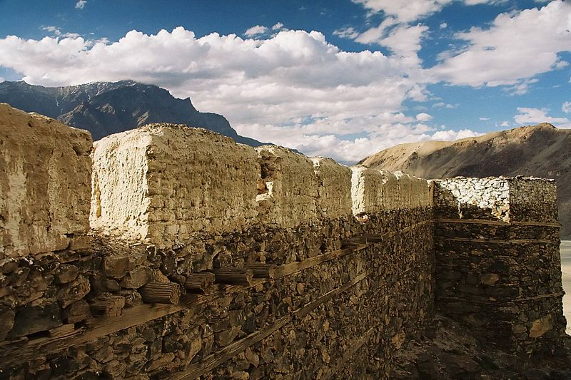

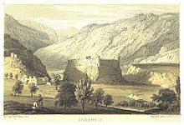

**Skardu Fort** or **Kharpocho** **The king of Forts** is a fort in Skardu city in Gilgit-Baltistan region of Pakistan. Australian mountaineer and film maker Greg Child writes that the fort is "perched above the junction of the rivers" and overlooks the Rock of Skardu. The fort was built by the king Ali Sher in the end of the sixteenth century. General Zorawar Singh of the Dogra Rajput clan working under Maharaja Gulab Singh realized the importance of the fort's location in the town and so he occupied the fort. It was part of his many military campaigns to annex the areas of Baltistan to the princely state of Jammu and Kashmir. The fort was razed to the ground in 1857 under the guidance of Ranbir Singh. Mughal emperor Aurangzeb also tried to occupy the fort, which went in vain.